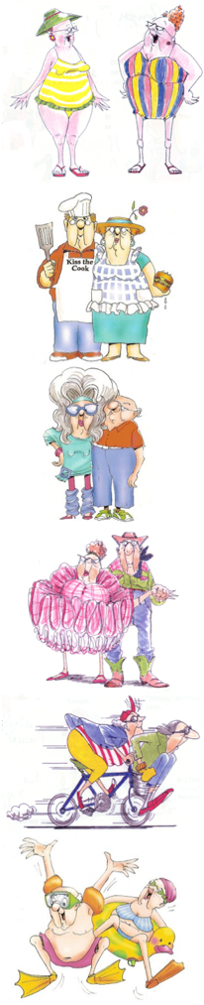

**Nan’s & Pop’s need only apply!**

Our canteen is seeking grandparent* volunteers.

We understand that golf, dancing, cycling, shopping, cooking classes, swimming, and bingo are exciting - but so is our canteen! Bring back the memories of when you worked in the school tuck-shop.

**Your duties for the day will be:**

* Making easy lunches for our fabulous students
* Serving at recess and lunch
* Having a good laugh, lots of fun and a chat
* Option to bring along a friend or two!

**And for your valued time we will provide you with a:**

* Healthy lunch
* All the tea and coffee you can drink

Please contact [supervisors name] on [phone number]

*Due to insurance purposes you must be under the age of 75