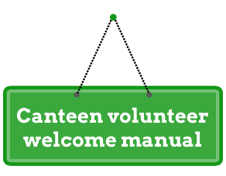

Welcome and thank you for joining our [Insert school name] canteen community! It would be impossible for our canteen to operate as a healthy and affordable service for students without your time and help.

There are many benefits to volunteering in your school canteen such as learning new skills and making new friends.

We hope this manual provides you with the information you need to get started however if you have any questions please feel free to come by the canteen or contact our canteen manager:
[Insert manager name and contact details]

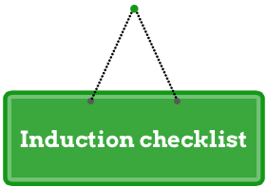

Staff member completing the induction: ______________________________________

Volunteer name: ____________________________________________

Induction date: ______________________

Action | Completed
1. Introduction to canteen staff & site (include bathroom locations)
2. Menu and volunteer duties

3. Shift reminders

4. Food safety training and copy of canteen policy provided
5. Location of first aid, fire safety equipment and emergency procedures
6. Hazard areas and workplace health and safety including reporting procedures
7. Use of health and safety personal protective equipment
8. Use of chemicals – sanitiser spray, surface spray and dishwashing liquid
8. Copy of working with children check (if applicable)

Comments: __________________________________________________________________________________________________________________________________________________

This information has been provided to me as a volunteer at the school canteen:

____________________________________________ ______________________
Volunteer name and signature Date

____________________________________________ ______________________
Canteen manager name and signature Date

Operating days: [Monday to Friday]
Operating hours: [00:00 to 00:00]

Roster
All our volunteers are rostered according to their preferred days whenever possible. Occasionally it can be difficult to accommodate everyone’s individual preferences. Our canteen roster can be found [insert details].
Shifts are [00:00 to 00:00] during the school term. Due to limited staff resources in the canteen, volunteers are an essential part of the team and every minute counts, so if you need to leave early or will be arriving late please let us know.

If you are unable to make your shift please try to find a replacement yourself first then contact [Insert manager name and contact details] or our school office [Insert school office details] to let us know at your earliest convenience.

Lunch and morning tea
Lunch and morning tea are provided to our volunteers during their shift up to the value of [$0.00]. Unlimited tea and coffee is available throughout your shift.

Description of duties
Volunteer duties vary depending on the day and the requirements of that particular day. Volunteer duties generally include but are not limited to:
- Serving students at recess [00:00 to 00:00] and lunch time [00:00 to 00:00]
- Preparation of sandwiches and salads
- Labelling and sorting lunch bags
- Toasting sandwiches
- Packaging hot foods
- Restocking fridges and freezers
- Making up popcorn, jelly cups, veggie sticks and other snacks as required
- Washing, drying and putting away equipment
- Adhering to the policies of the canteen, including work health and safety and food handling procedures, as outlined by our canteen manager.

Shift reminders
- Always ensure you are signed in at the front desk (school requirement for evacuation procedures)
- Hair tied back
- No toes exposed – enclosed shoes must be worn at all times
- Jewellery off
- Bags and valuables in designated area – please try to leave all valuables at home
- Mobile phone on silent
- Hands washed
- Apron and hair covering on
- Task allocation for the day, location of run sheet and recipe cards
- Please note there is no smoking permitted on the school premises at any time

If you have any questions or feedback at any time, please have a chat to us or fill out a canteen feedback form at the school office.

[Insert your canteen policy]
*Include nut/allergen policy if applicable.

Note: As part of compliance with the Department of Education’s Healthy Food and Drink Policy ALL schools are required to have a written school canteen/food service policy.

[Insert canteen menu]

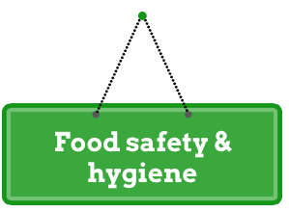

[Insert food safety and hygiene information or adapt our example from below]
School canteens are classified as a food business by law. Food Safety Standards are applied throughout Australia and provide the minimum requirements to handle food safely. As a volunteer you must be able to demonstrate skills and knowledge to prepare food safely and will be provided training to do so today.

The main points to remember for our canteen include:
- Sign in and out for your shift at the school office
- Wear clean and neat clothing with sleeves, no singlet tops permitted, enclosed shoes
- Jewellery off
- Valuables and bags in designated areas, mobile phone on silent and in bag
- Hair tied back if long, hair net or covering will be supplied by our canteen
- A clean apron must be worn and will be supplied by our canteen, aprons must be discarded or washed after each shift and not shared between staff
- Hair covering and apron must be taken off each time you leave the canteen and hands must be washed before you re-enter the canteen and put your apron and hair covering back on
- No children allowed in the canteen at any time – if your child wishes to visit you, you will need to step out of the canteen
- Hand washing
- Safe food storage – food at room temperature:
- For under 2 hours can be used immediately or refrigerated
- 2–4 hours can be used immediately but cannot be refrigerated
- Over 4 hours must be thrown away
- All food in refrigerators need to be:
- Dated when opened if commercial or if homemade note the date made
- Stored in clear containers
- All frozen foods require labelling with the date made or frozen if homemade

We are obligated by law to follow these safety requirements. If you are unable or unwilling to comply with these points you will unfortunately not be allowed to commence your shift.

*If you are not a parent or primary carer of a child at the school you will be asked to obtain a working with children check (WWC Check) before commencing work within our canteen.

[Insert your work health safety information or adapt our example from below]
All volunteers are required to adhere to the policies of the canteen, including Work Health and Safety and food handling procedures. Work Health and Safety is the responsibility of everyone in the workplace.

Footwear
No toes exposed – enclosed shoes must be worn at all times. Heels or thongs can be unsafe and are not permitted in the canteen.

Sharp objects
The canteen is a food service business and requires the use of knives and other sharp objects in the preparation of foods. Please ensure that your knife is sharp and cutting board secure when using them. If you are uncomfortable using a knife or you cut yourself, please let us know immediately. Do NOT place knives into sinks filled with water. It can be difficult to see what is under the water and other people may cut themselves if they put their hands in.

Hot zones
There are many ‘hot zones’ in the canteen. These include the pie warmer, oven, toasters, hot plates, fry pans, Zip hot water heater, popcorn maker and hot water taps. Please use caution when working in and around these zones. Always use utensils to handle food and use hand protection such as oven mitts when taking trays from the oven. Do not leave hot trays, pots or utensils unattended.

Chemicals
During your shift in the canteen you may be handling chemicals such as dishwashing liquid, sanitiser and general-purpose spray cleaner. Ensure you wash your hands after use. You should not handle any other chemicals during your shift.

Lifting and bending
Please use caution when lifting any item. When lifting ensure you have a good grip and keep the load close to your body, this helps by keeping your centre of gravity over the feet and keeps back strain to a minimum. Bend your knees and lift with your legs, not your hips or back. When lowering your load ensure you bend the knees again. Avoid lifting with a fully bent back, when your back is twisted or bent sideways, after prolonged periods where your back has been bent or when you have been sitting for a long duration.
During your shift you will not be required to do any heavy lifting. Any lifting above 14kg requires two people.

Spillages on the floor
Report any spillages on the floor immediately. Ensure the spill is cleaned up, that signage is placed over the spill and avoid the work area until the spill has dried.

Electrical appliances
Please use caution when using electrical devices in the canteen and do not use them unless you have received instruction. Do not use electrical devices near running water or that appear damaged in any way.

Boiling liquids
Please show extreme caution when working with boiling liquids, including from the kettle or a Zip hot water heater. Even a cup of coffee can be dangerous. If you are carrying hot liquids, make sure you have the correct hand protection, the floor is dry and clear of obstacles where you are working/walking and inform all other people in the canteen you are handling/moving a hot liquid. It’s also important to be very careful with steam when opening oven doors, sandwich presses or taking lids off pots.

Illness
Many food poisoning incidents are caused by people who continue to handle food after falling ill themselves. If you are unwell or have been in close contact with someone who is unwell, please do not attend your shift.

[Insert your school map]

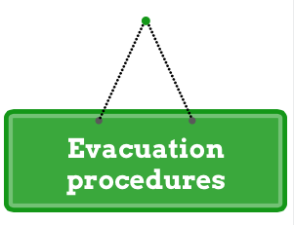
[Insert your school evacuation procedure and map of evacuation points]

