

**Join our team of canteen volunteers and meet a fun and supportive team!**

**Drop by the canteen for a chat or contact (name phone, email)**

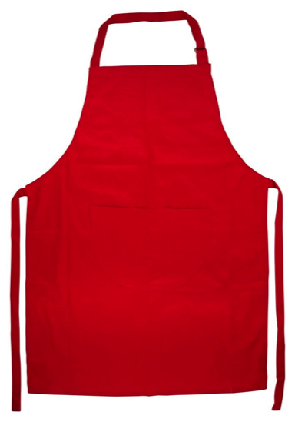

**Canteen**

**volunteers required!**

**Masterchefs and sandwich experts welcome!**

**Drop into the canteen for a chat or contact (name phone, email)**

**HELP NEEDED!**

Canteen volunteers!

Enjoy a fun team and unlimited cups of tea!  
Drop into the canteen for a chat or contact (name phone, email)