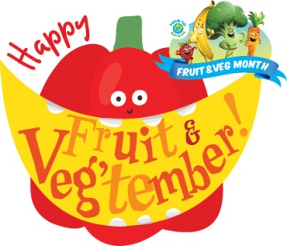
Fruit & Veg Jokes

- Q: What do you call a group of strawberries playing the guitar?
A: A jam session.

- Q: What do you call an angry pea?
A: Grump-pea.

- Q: What kind of apple isn’t an apple?
A: A pineapple!

- Q: What's a vegetable's favourite martial art?

A: Carrot-eee!

- Q: What kind of shoes are made from banana peels?
A: Slippers.

- Q: What is green and goes camping?
A: A Brussel scout!

- Q: How did the farmer fix his jeans?
A: With a vegetable patch.

- Q: What’s worse than biting into an apple and finding a worm?
A: Biting into an apple and finding half a worm.

- Q: What vegetable likes looking at animals?
A: A zoo-chini!

- Q: What’s the strongest vegetable?
A: A muscle sprout!

- Q: What vegetable did Noah leave off the ark?
A: Leaks.

- Q: Why did the tomato go out with the prune?
A: Because he couldn’t find a date.

- Q: What sort of exercise does the fruit do?
A: Avo-cardio.

- Q: What do you call a fast fungus?
A: A mush-vroom!

- Q: How do you fix a broken tomato?
A: With tomato paste.

- Q: If you had 5 potatoes in one hand and 6 leaks in the other hand, what would you have?
A: Massive hands!

- Q: How does a lemon ask for a hug?
A: Give me a squeeze!

- Q: Why did everyone like to dance to the vegetable band?
A: Because they have a good beet!

- Q: What did the baby corn say to the mother corn?
A: Where’s pop-corn?

- Q: What’s green and comes down a mountain in the snow?
A: A skiwi.

- Q: Why was the green pea laughing?
A: Because she was hap-pea.

- Q: What did the olive say to his wife on valentine’s day?
A: Olive you very much.

- Q: Why didn’t the piece of corn get the joke?
A: He was corn-fused.

- Q: Why did the lemon cross the road?
A: To make lemon squash.

- Q: What’s orange and sounds like a parrot?
A: A carrot.

- Q: What did my Mum say when she drank MY strawberry milkshake?
A: That was berry nice!

- Q: Why shouldn’t you tell secrets on a farm?
A: Because potatoes have eyes, beans-talk and corn has ears!

- Q: What did the vegetable say when the piece of fruit said he looked orange in the face?
A: I don’t carrot-all

Sources:
- http://www.k12.wa.us/ChildNutrition/programs/FFVP/pubdocs/Jokes.pdf
- http://www.freshforkids.com.au/kids-corner/fruit-jokes/
- http://www.yukonfromthegroundup.ca/veggiejokes.php
- https://www.smh.com.au/cqstatic/gnt6rm/Jokes-vegetable.pdf
- https://www.buzzfeed.com/jamiejones/pure-and-wholesome-jokes-about-fruit?utm_term=.qljbY1ME9#.ff1nxbo4J
- http://www.essentialkids.com.au/activities/kids-worksheets/fruit-jokes-for-kids-20160329-gnt7iw
- http://4riddles.com/category/tags/vegetables

