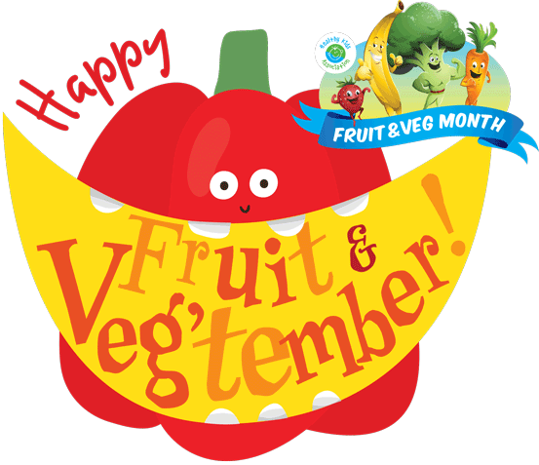
Who Am I?
Banana:
I grow on a tree.
I am really a berry but you wouldn’t think so by how I look.
I can be green or yellow.

Kiwifruit:
I grow on a vine.
I can have furry or smooth skin.
My flesh can be green or gold.

Peach:
I have furry skin.
I smell delicious!
I have a large stone inside.

Leek:
I am from the same family as onions.
I am green and white.
I am long and straight.

Peas:
I am green.
I am only small.
I grow in a pod.

Watermelon:
My flesh can be yellow, orange, white or red.
I am a fruit that grows on a vine and I am in the same family as pumpkins.
I am delicious served cold on a hot day.

Avocado:
In some places I am called an alligator pear.
You can use me instead of butter on your sandwich.
I grow on a tree.

Sweet potato or kumara:
I am a vegetable that comes in lots of colours including orange and purple.
I am a large root.
I am not a potato but some people call me a type of potato.

Pumpkin:
I can grow very, very large.
I am very popular at Halloween.
I am usually orange.

Potato:
I come in more than a thousand different types.
I am eaten all over the world.
I usually have white flesh but I can be blue!

Grapes:
I grow on vines.
I can be eaten raw or cooked.
I can be made into lots of things like jam, juice, vinegar, and oil.

Pineapple:
I am a fruit that forms from up to 200 flowers.
I have been named because I look like a pine cone.
I grow in tropical areas.

Blueberry:
I am a berry related to the sparkleberry, farkleberry, whortleberry and partridgeberry.
I grow on a bush.
When ripening, I change from green to pink and then to blue.

Zucchini:
I can grow up to a metre long!
I can be green, yellow or stripey.
I am sometimes called a courgette but in Australia I am called a…

Corn:
I grow as an ear.
I can be popped.
I am usually yellow

Carrots:
I am one of the crunchiest vegetables.
I am related to parsley
I am a root.

Lemon:
I am very sour.
I am yellow.
I grow on a tree.

Tomato:
I am really a fruit but get used as a vegetable.
I am easy to grow and lots of people will have a go at growing me in their backyard in summer.
You will find me in lots of different colours including red, orange, yellow and green.

Beetroot:
I grow in the ground.
I am usually red.
You can use me to colour pasta red.

Onion:
I grow in the ground.
I can be brown, white or red.
I might make you cry.

