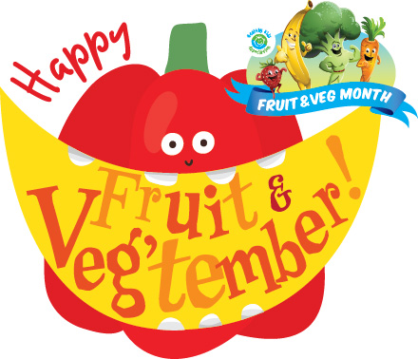

Fruit & Veg Month Permission Form

3rd September – 28th September 2018

Dear parents/guardians/carers,

Our school is celebrating Fruit & Veg Month!

This is a great program that will educate your child about the benefits of eating fruit and vegetables as part of a healthy lifestyle.

Activities will cover a range of curriculum outcomes. Some activities involve students taste testing fruits and vegetables. Some students may have allergies/intolerances to certain foods. We ask for your co-operation in completing this permission slip.

If you have any enquiries about the program, please do not hesitate to contact the school or your child’s teacher.

Please return the form to ___________________ by ____________.

Regards

--------------------------------

Fruit & Veg Month School Coordinator

------------------------------------------------------------------------------------------------------------------

Fruit & Veg Month Permission Slip

3rd September – 28th September 2018

I ________________________ give permission for my child/ward _________________________ of class __________________ to participate in the Fruit & Veg Month tasting activities at _______________________________________________School.
This activity has the approval of the Principal.
Please tick

________________ has no known food allergies/intolerances.
(insert name of child)

Please tick

________________ does suffer from a food allergy/intolerance
(insert name of child)

and is not allowed to consume the following foods (complete only as necessary):
____________________________________________________________________________________________________________________________________________________________

Signed:_____________________________ Date___/___/2018
(parent/guardian/carer)

