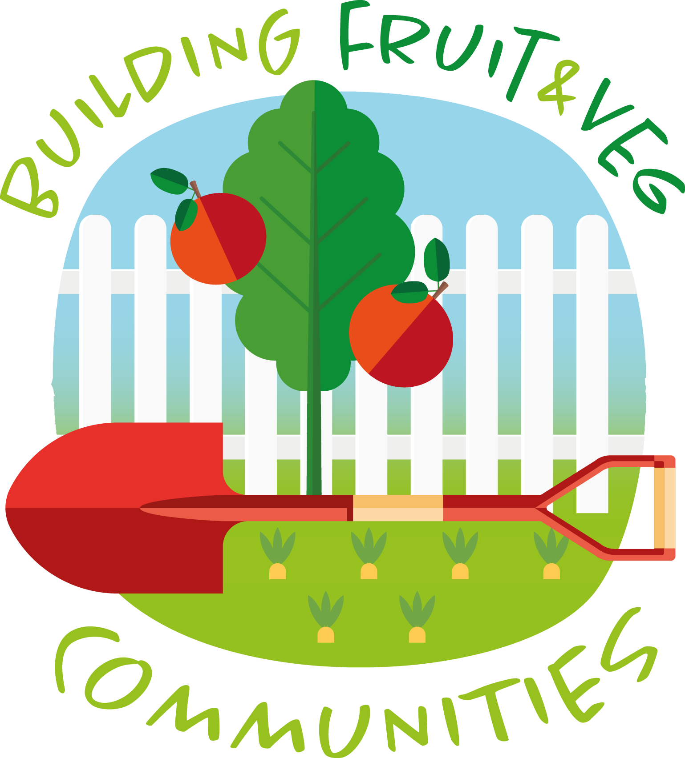
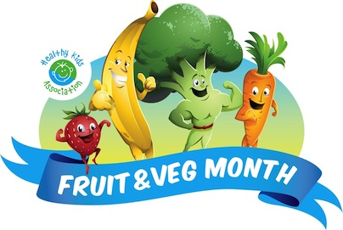

Fruit & Veg Month Permission Form

29 August – 23 September 2022

Dear parents/guardians/carers,

Our school is celebrating Fruit & Veg Month!

Fruit & Veg Month is a health promotion event that educates students on the benefits of eating fruit and vegetables.

Activities will cover a range of curriculum outcomes. Some activities involve students taking a field trip to a nearby community garden, guided by teachers.

Your child’s class will go to __________________________________________ (name/location community garden on ________________________(date).

If you have any enquiries about the event, please do not hesitate to contact the school or your child’s teacher.

Please return the form to ___________________ by ____________.

Regards

______________________________

Fruit & Veg Month School Coordinator

------------------------------------------------------------------------------------------------------------------

Fruit & Veg Month Permission Form

29 August – 23 September 2022

I ________________________ give permission for my child/ward _________________________ of class __________________ to participate in the Fruit & Veg Month community garden field trip activity at _______________________________________________ School.

Signed:_____________________________ Date___/___/2022
(parent/guardian/carer)

