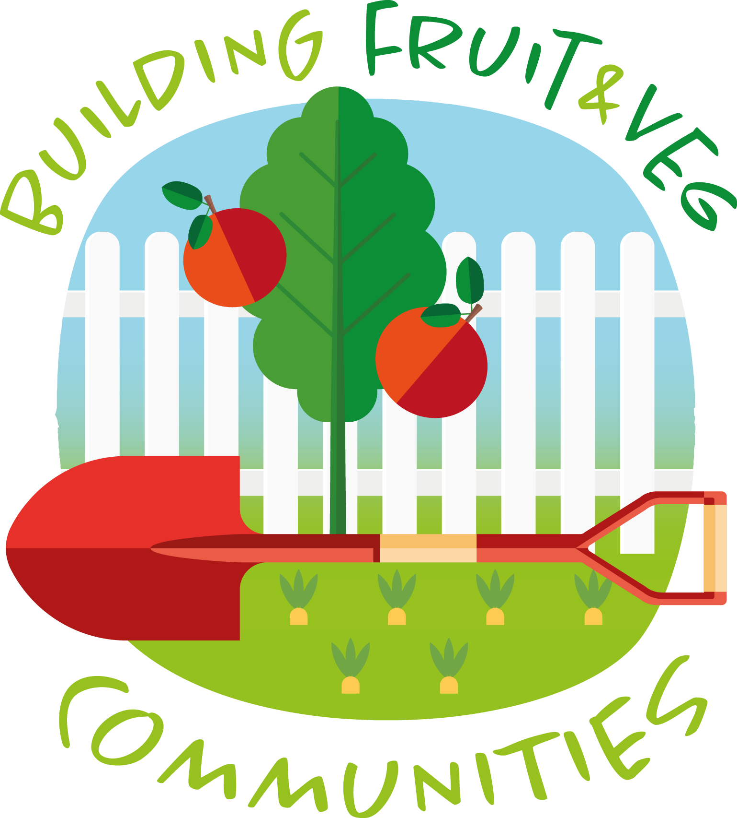
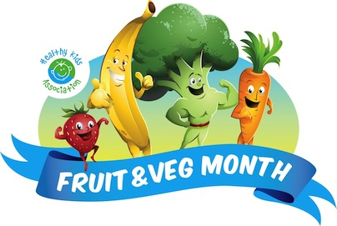

Fruit & Veg Month Permission Form

29 August – 23 September 2022

Dear parents/guardians/carers,

Our school is celebrating Fruit & Veg Month!

Fruit & Veg Month is a health promotion event that educates students on the benefits of eating fruit and vegetables.

Activities will cover a range of curriculum outcomes. Some activities involve students taste testing fruit and vegetables. Some students may have allergies/intolerances to certain foods. We ask for your co-operation in completing this permission slip.

If you have any enquiries about the event, please do not hesitate to contact the school or your child’s teacher.

Please return the form to ___________________ by ____________.

Regards

______________________________

Fruit & Veg Month School Coordinator

------------------------------------------------------------------------------------------------------------------

Fruit & Veg Month Permission Form

29 August – 23 September 2022

I ________________________ give permission for my child/ward _________________________ of class __________________ to participate in the Fruit & Veg Month tasting activities at _______________________________________________School.

Please tick

________________ has no known food allergies/intolerances.
(insert name of child)

Please tick

________________ does suffer from a food allergy/intolerance
(insert name of child)

and is not allowed to consume the following foods (complete only as necessary):
____________________________________________________________________________________________________________________________________________________________

Signed:_____________________________ Date___/___/2022
(parent/guardian/carer)

