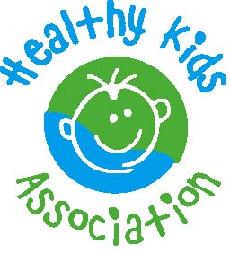
MEDIA RELEASE

NAME OF SCHOOL IS ENCOURAGING STUDENTS TO BUILD A STRONG LOCAL FRUIT & VEG COMMUNITY

XX August 2022
_____________________________________________________________________________

Fruit & Veg Month is a fun and free event for NSW primary schools that puts a positive focus on fruit and vegetables for an entire month. Fruit & Veg Month 2022 will be held from Monday 29 August to Friday 23 September.

Each year Fruit & Veg Month has a special theme to inspire kids to get interested in eating, enjoying and learning about fruit and vegetables. This year’s theme ‘Building Fruit & Veg Communities’ encourages school communities to grow and buy local fruit and veg.
Local community-based initiatives connect school community members, create local food supply and encourage people to eat more fruit and vegetables. Children also learn more about growing fruit and vegetables, preparing healthy meals and tasting new fruit and vegetables at school, from the canteen and with their families.
Name of School will join hundreds of other schools across NSW to explore this concept during Fruit & Veg Month in 2022, with the theme ‘Building Fruit & Veg Communities.’

“This year’s theme encourages school communities to grown and buy local fruit and veg,” says Healthy Kids Association Senior Project Officer Nienke de Vlieger. “This is good for our environment, for our health, for creating local food supply and for building strong community networks. It allows us all to feel a greater connection to fruit and vegetables, which can encourage eating more – and a wider variety of – produce.”

Students at Name of School can’t wait to explore what this means in Name of region/area/suburb.

For more information, visit fruitandvegmonth.com.au.

Contact

For more information about Fruit & Veg Month at Name of School, please contact Name, title, email / phone number of contact person.

For more information about the event or to arrange a high-res copy of the event logo, please email Senior Project Officer Nienke de Vlieger at info@healthy-kids.com.au.

About Healthy Kids Association

- Established in 1991, the Healthy Kids Association is a health promotion charity that works to reduce the incidence of diet-related diseases in children such as obesity
- It aims to educate and empower families, children and school canteens to make the healthiest choices possible. Its nutrition philosophy is one of balance that promotes the five core food groups, variety and mindful eating
- Staffed by dietitians, teachers and health educators, Healthy Kids provide a range of services including a toll-free telephone enquiry line, email support, canteen menu reviews and more
- See the website for more information: healthy-kids.com.au

