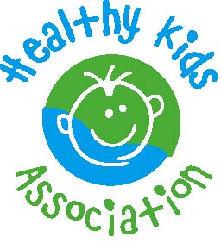
MEDIA RELEASE

[NAME OF SCHOOL] IS GETTING INTO FRUIT & VEGIE STEMS

XX August 2023
_____________________________________________________________________________

Fruit & Veg Month is a fun and free event for NSW primary schools that puts a positive focus on fruit and vegetables for an entire month. Fruit & Veg Month 2023 will be held from Monday 28 August to Friday 22 September.

Each year Fruit & Veg Month has a special theme to inspire kids to get interested in eating, enjoying and learning about fruit and vegetables. This year’s theme ‘Fruit & Vegie STEMs’ is about learning about fruit and vegetables through subjects like maths, science and technology.
Students will get curious and look at the science, maths and technology of fruit and veg.
- What do they need to grow?
- How do they get transported and stored so they keep fresh and safe?
- What happens in our bodies when eat them?
- How to do a fruit & veg science experiment
The whole community will also take part in fun school, canteen and home activities.
[Name of School] will join hundreds of other schools across NSW to explore this concept during Fruit & Veg Month in 2023, with the theme ‘Fruit & Vegie STEMs.’

“This year’s theme encourages students to explore fruit and veg from a new and exciting angle” says Healthy Kids Association Senior Project Officer Nienke de Vlieger. “It allows children to connect to fruit and vegetables on a different level, which can encourage eating more – and a wider variety of – produce. We hope this sparks a life-long love for fruit and veg, or even an interest in STEM”

For more information, visit fruitandvegmonth.com.au.

Contact

For more information about Fruit & Veg Month at [Name of School], please contact [Name, title, email / phone number of contact person].

For more information about the event or to arrange a high-res copy of the event logo, please email Senior Project Officer Nienke de Vlieger at info@healthy-kids.com.au.

About Healthy Kids Association

- Established in 1991, the Healthy Kids Association is a health promotion charity that works to reduce the incidence of diet-related diseases in children such as obesity
- It aims to educate and empower families, children and school canteens to make the healthiest choices possible. Its nutrition philosophy is one of balance that promotes the five core food groups, variety and mindful eating
- Staffed by dietitians, teachers and health educators, Healthy Kids provide a range of services including a toll-free telephone enquiry line, email support, canteen menu reviews and more
- See the website for more information: healthy-kids.com.au

